**Report on SilverOctoMoviebase**

I wanted to have a page for each section/feature of the app. I used the Expo Navigation library to navigate the switching between different pages. I chose to nest my navigators where my “Home” component contains tab navigators so that I can navigate through important pages using the tab navigators at the bottom and enter different pages through stack navigators.

My HomeScreen.js is a page which contains popular movies. I am using the hook useState() to store and update my json dataset with its function. Using useState() is better than just using a variable but it rerenders the view which hinders the state of the app getting out of sync. I set the data using the hook useEffect () to update the json data on every render. The data displayed on the homescreen is from a json file from themoviedb because the application would sometimes take a long time to get the data from an API fetch. To display the posters, I use the poster_path from each item which is passed to a uri. The Image is wrapped in a TouchAbleWithoutFeedback to make it possible to press the Image and navigate to the next page using Navigation. I am using a FlatList to render the data that is currently shown on the display in the Popular Movies page instead of rendering all the data resulting in better performance as a moviedb can contain a lot of data. For this project I could have used ScrollView for showing movies, but it would not scale well because ScrollView loads all content at once resulting in performance issues.

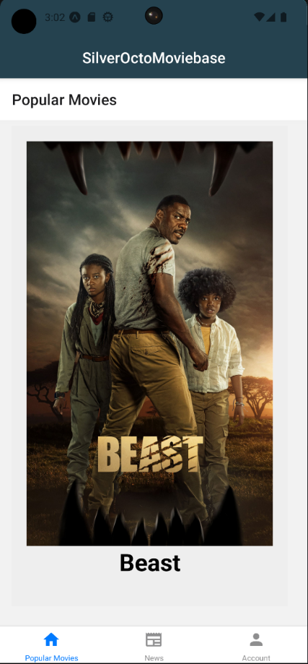To navigate to the details of a movie, you can either press on the picture or the title which will navigate you to the next page containing more information about the movie. I pass the movie_id data to the details_screen because I am using the movie_id to fetch specific movie details from TheMovieDB API which are used to populate the page with data. I use the same hooks as the HomeScreen.js because I want the data to be rendered and in sync. The image is fetched using the data about poster_path from the API. I use ScrollView in DetailsScreen.js to make it possible to scroll long descriptions.